**HTML(Hypertext markup language)**

**CHAPTER 1**

* + - * HTML is the structure of web page.
      * Learning HTML is the first step of creating web sites
      * HTML contains series of elements.
      * HTML elements tells the browser how the display the content.
      * The <body> element defines the document's body, and is a container for all the visible contents, such as headings, paragraphs, images, hyperlinks, tables, lists, etc.
      * 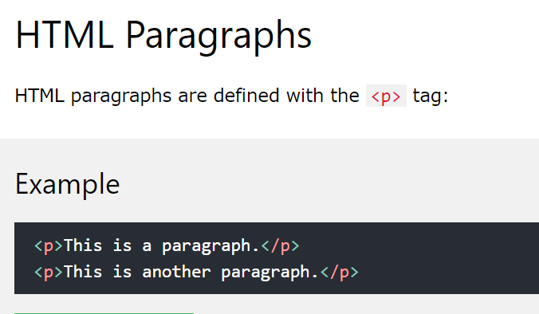<element>content</element> So in html content will always gonna stay between the element tag we using. Element could be
      * <h1>…..</h1> ===== Heading element
      * <p>…</p> ======= Paragraph element
      * <img src = “ ……..” > Image element
      * 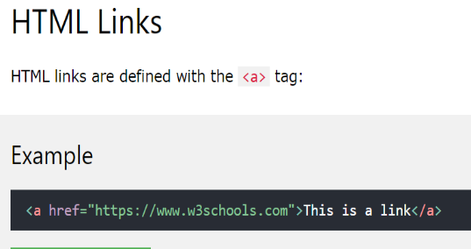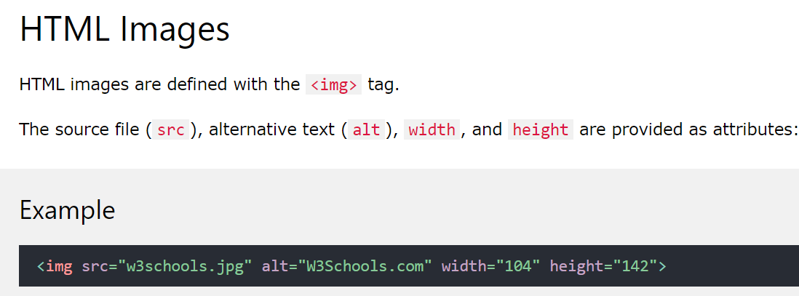The link's destination is specified in the href attribute.
      * **List of tag** [*https://www.w3schools.com/tags/default.asp*](https://www.w3schools.com/tags/default.asp)

**ATTRIBUTE**

* 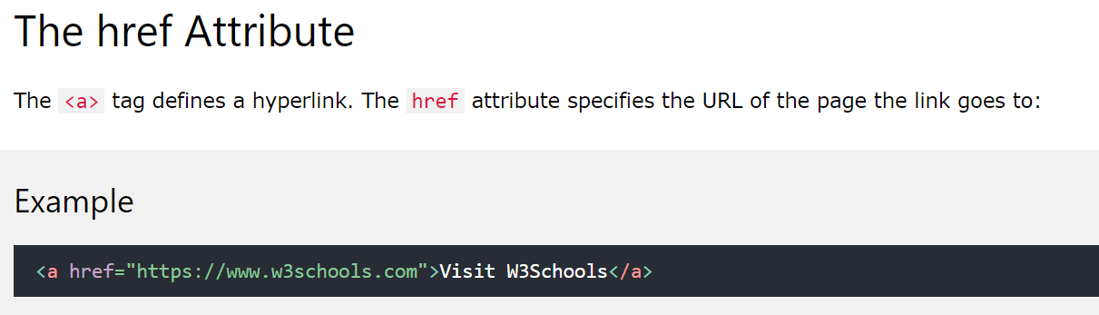All HTML elements can have attributes.
* Attributes are always specified in the **start tag.**
* Attributes usually come in name/value pairs like: **name="value".**

**src Attribute** 

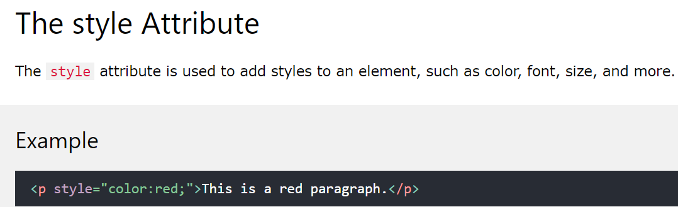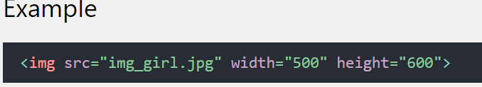

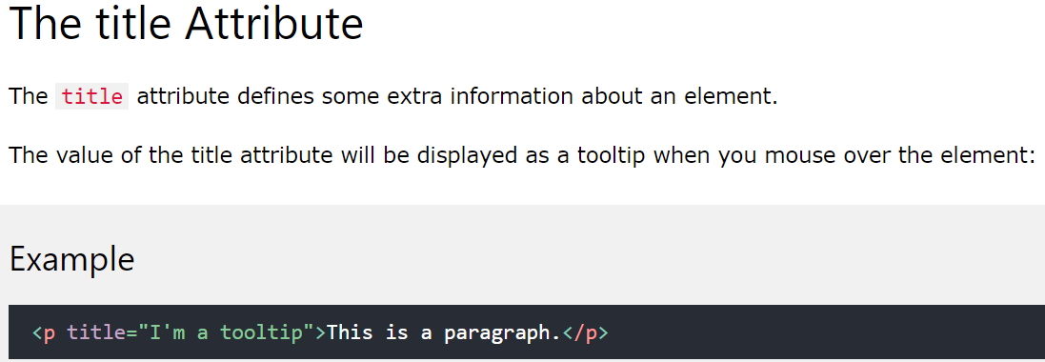

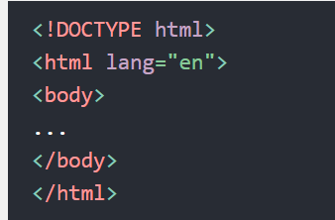

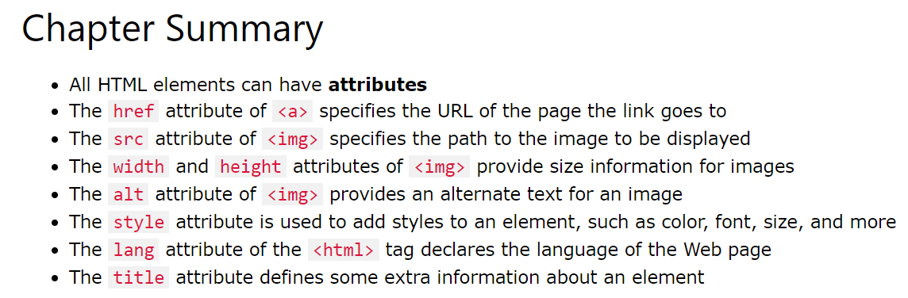

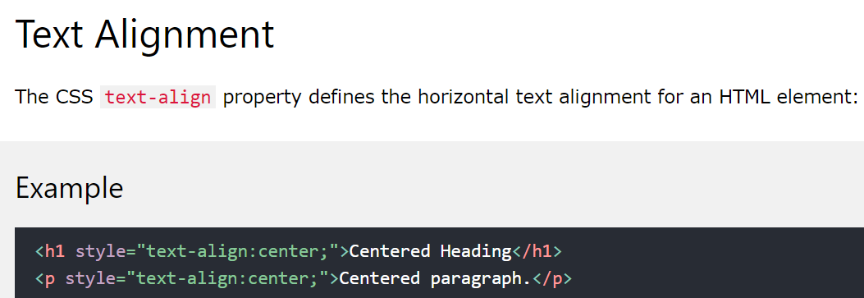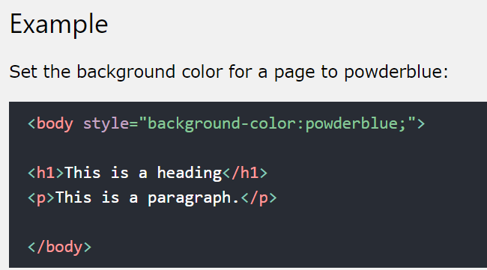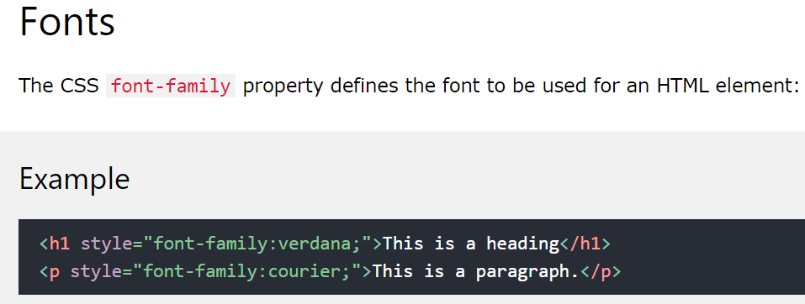

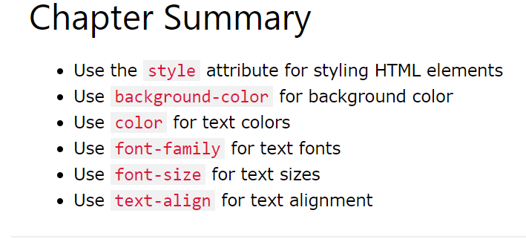

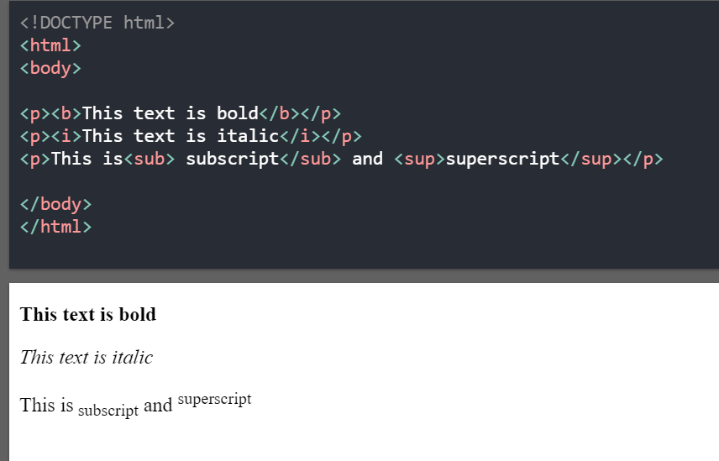**FORATTING**

<b>..</b> “Bold:

<sub>...</sub> “subscript”

<sup>..</sup> “super subscript”

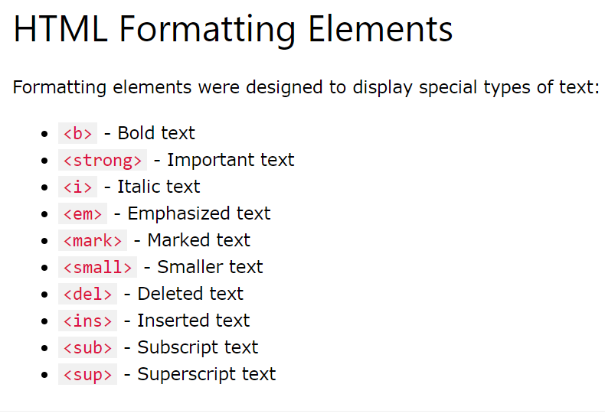

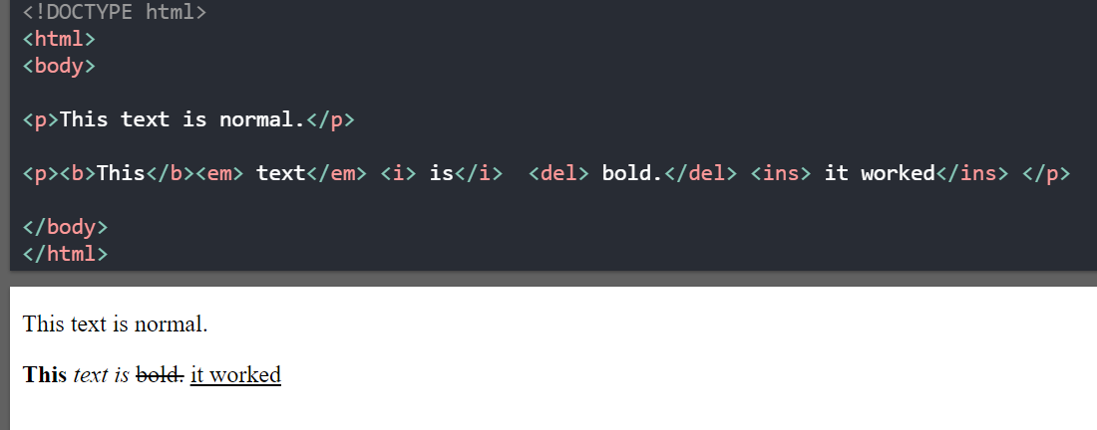

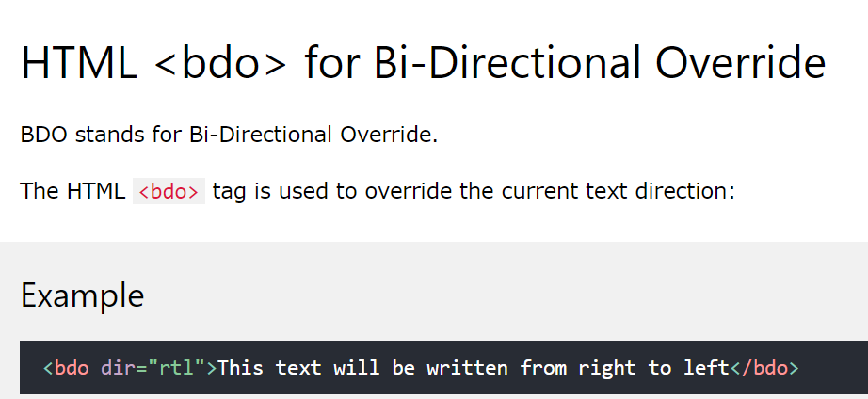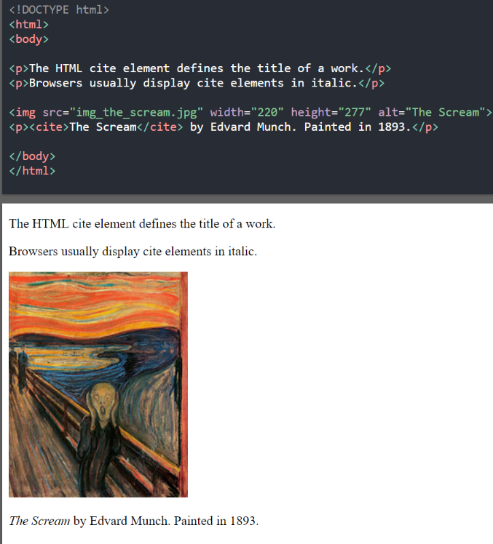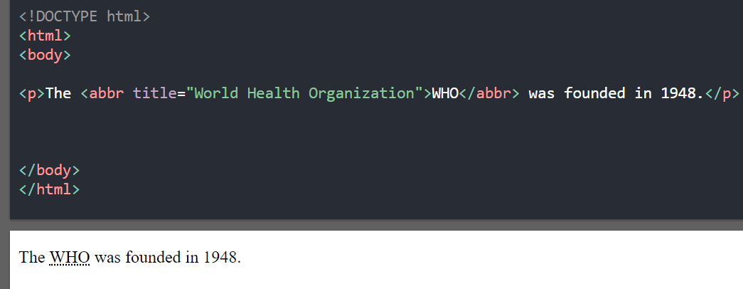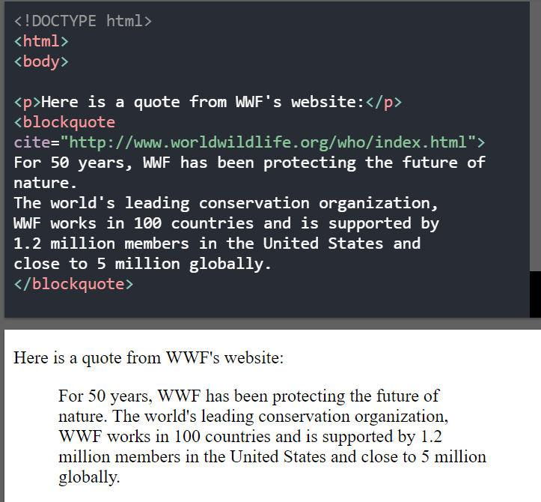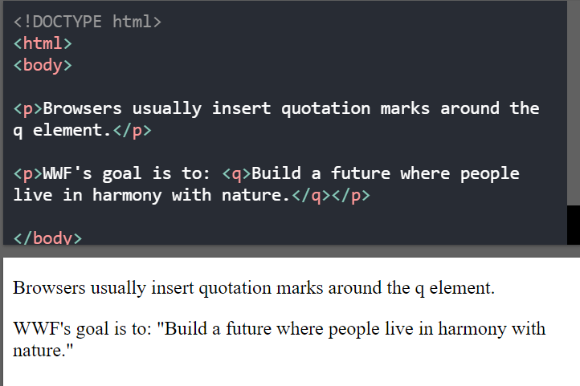**QUOTATIONS**

**HTML Color**

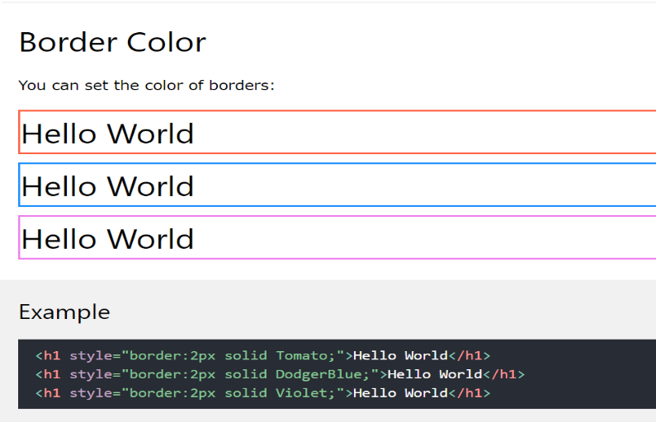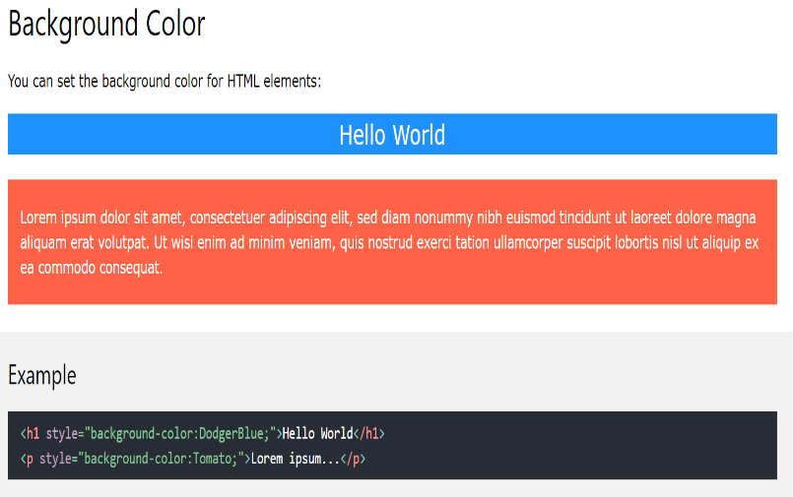

**RGB color**

An RGB color value represents RED, GREEN, and BLUE light sources.

An RGBA color value is an extension of RGB with an Alpha channel (opacity).

Each parameter (red, green, and blue) defines the intensity of the color with a value between 0 and 255.

For example, rgb(255, 0, 0) is displayed as red, because red is set to its highest value (255), and the other two (green and blue) are set to 0.

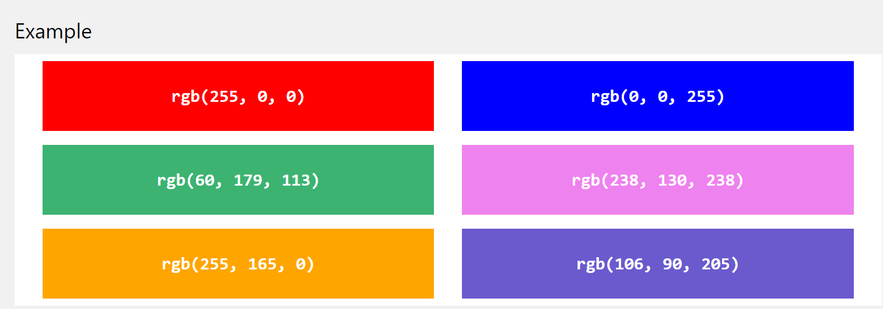

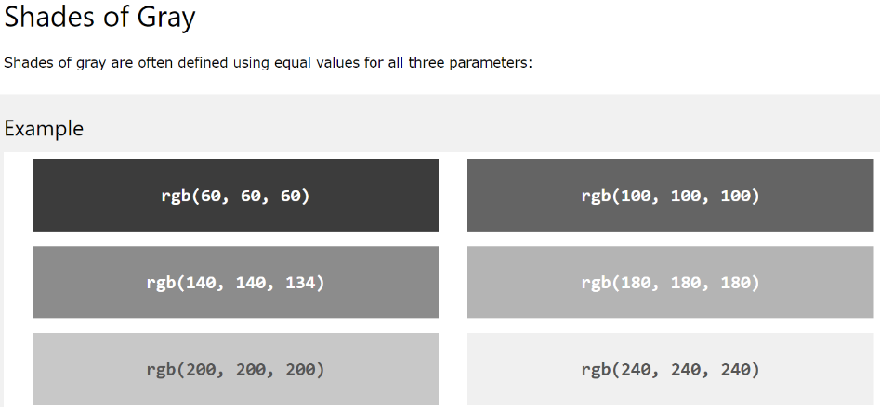

# 

# HTML HEX Colors

# A hexadecimal color is specified with: #RRGGBB, where the RR (red), GG (green) and BB (blue) hexadecimal integers specify the components of the color.

Where rr (red), gg (green) and bb (blue) are hexadecimal values between 00 and ff (same as decimal 0-255).

For example, #ff0000 is displayed as red, because red is set to its highest value (ff), and the other two (green and blue) are set to 00.

Another example, #00ff00 is displayed as green, because green is set to its highest value (ff), and the other two (red and blue) are set to 00.

To display black, set all color parameters to 00, like this: #000000.

To display white, set all color parameters to ff, like this: #ffffff.

